Progress Report
2021/10/19 Tanatat Thangkasemvathana

Progress
- Studied Sho Nakama’s Master Thesis, “Development of press molding method with unfolded diagram for CFRP”
- Attempted modification of Nakama-san core and cavity designs on Solidworks platform – add clearance (625mm) for additional layers (5) for workpiece
  - Unable – unfamiliar interface
  - Set up Autodesk Fusion360
- Researched possible solutions to remedy bubble defects observed from Nishimura-san’s experiment
  - Vacuum hot press – too costly
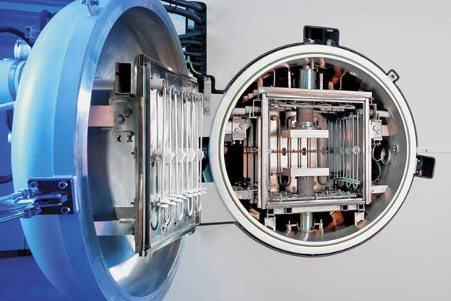
Figure 1: Vacuum Hot Press - Obtained from: https://www.vacfurnace.com/wp-content/uploads/2016/01/20150702_105615-169x300.jpg
- Expected more bubble defects with more layers of fiber orientations
  - Reduced mechanical properties – tensile strength, elasticity, thickness

Plan
- Continue study on Sho Nakama’s Master Thesis
- Convert Nakama-san core and cavity designs from Solidworks platform to Fusion360 platform for modification and improvement
- Modify design for 45 and -45 deg fiber orientations

